# Concept art

Confirm specifics about the direction for the game in terms of platform, theme, narrative, setting, preferred art style (cartoon like or a bit more realistic)

* **Platform**
  + PC: No reason for this except ease of development. Ideally if options became available, the game would also go out to other platforms. The gameplay/controls are not designed in a PC exclusive way.
* **Theme**
  + Discovery, duty, redemption: The player character, Mark II, starts with no memory of his previous actions. As he learns more about what he is, where he came from, and what he was originally created to do, that is where the themes of duty and redemption come from.
  + Not only does Mark II try to undo all the bad that has happened, but so do the other characters who are partially responsible for the threat that has occurred.
  + This is also partially represented by Mark II’s physical appearance – as he starts the game broken, damaged and incomplete. As the story progresses, and Mark II learns more, and understands his part in the story, he becomes physically more complete and. By the end of the game, he is fully rebuilt, and stands as the heroic figure he was intended to be.
* **Narrative**
  + The narrative is told entirely from Mark II’s perspective; a severely damaged robot, with no memory of preceding events, waking up in an abandoned, mysterious research facility.
  + As Mark II explores more of the facility, he discovers it is full of hostile robots, who are all out to get him
  + Eventually, the player will discover that the leader of the hostile robots intends to unleash destruction against the planet, and that he must be stopped
* **Setting**
  + Game takes place in a secret underground research and development facility
  + A lot of experimental technology is developed, leading to it being full of contraptions both helpful and dangerous
  + The facility itself stretches across numerous levels, with the deepest, darkest levels holding the most dangerous technologies, and the upper levels being more open and safer
  + Although the game takes place in an entirely fictional world, the overall idea is that the level of technology isn’t too far out from our own – although everything is different in slightly off ways (e.g. data is stored physically instead of digitally, AI is more advanced, computer screens have portrait aspect ratios as opposed to landscape, etc). Essentially, an alternate reality aesthetic.
* **Preferred art style (scale from cartoony to realistic)**
  + My preference had always been to avoid the typical look of retro games – AKA trying to emulate 8 bit and 16-bit graphical styles
  + A look I had always sort of pictured in my head was something like some of the Animatrix short films – specifically The Second Renaissance – see the below images:

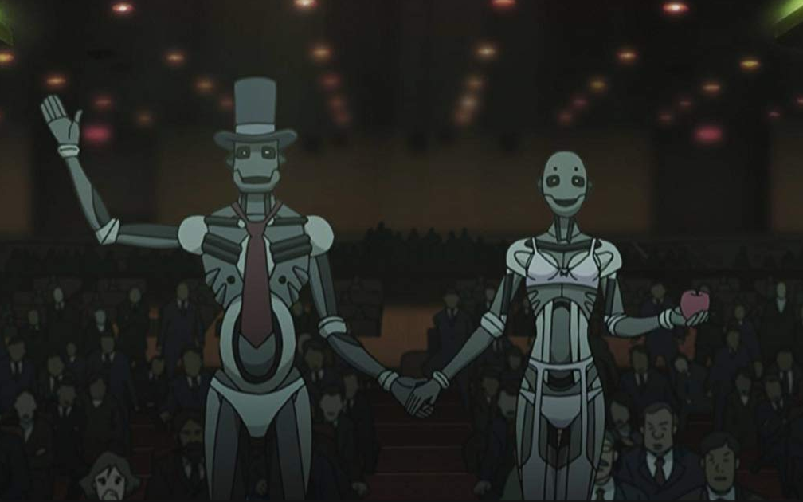 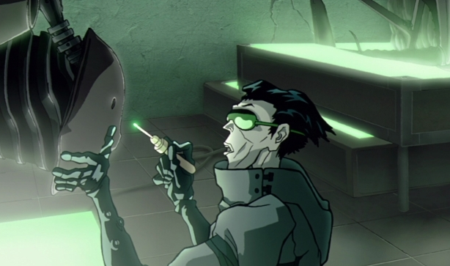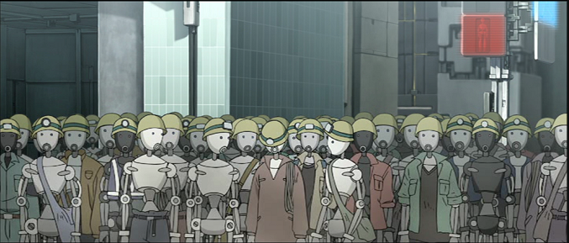

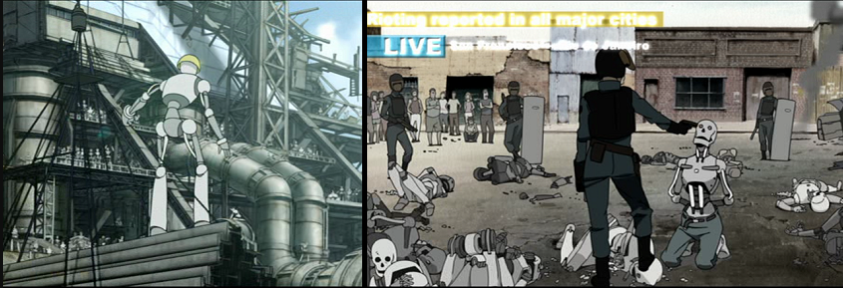

# Deliverables Priority

* **Focus: Character (Mark II)**
* Focus on the fully formed version of the character and the character at different stages of the game

Other (if time allows it):

* Props from the game/world (upgrade kits, energy vials, scrap, components)
* Different enemy types